TMJ assessment:

Anatomy :

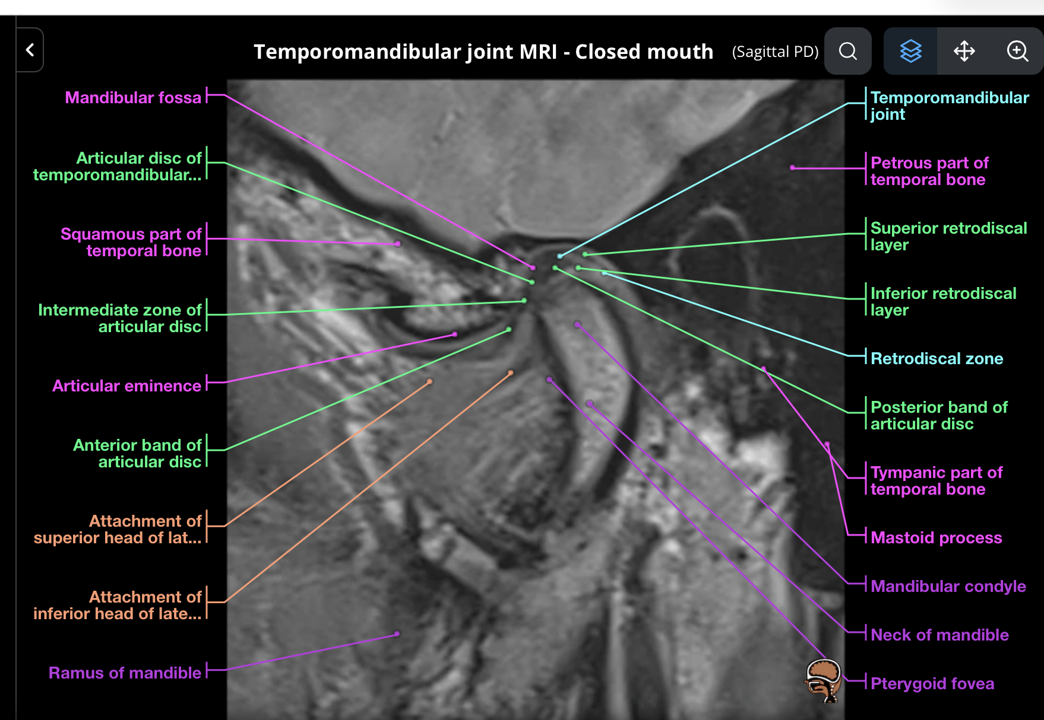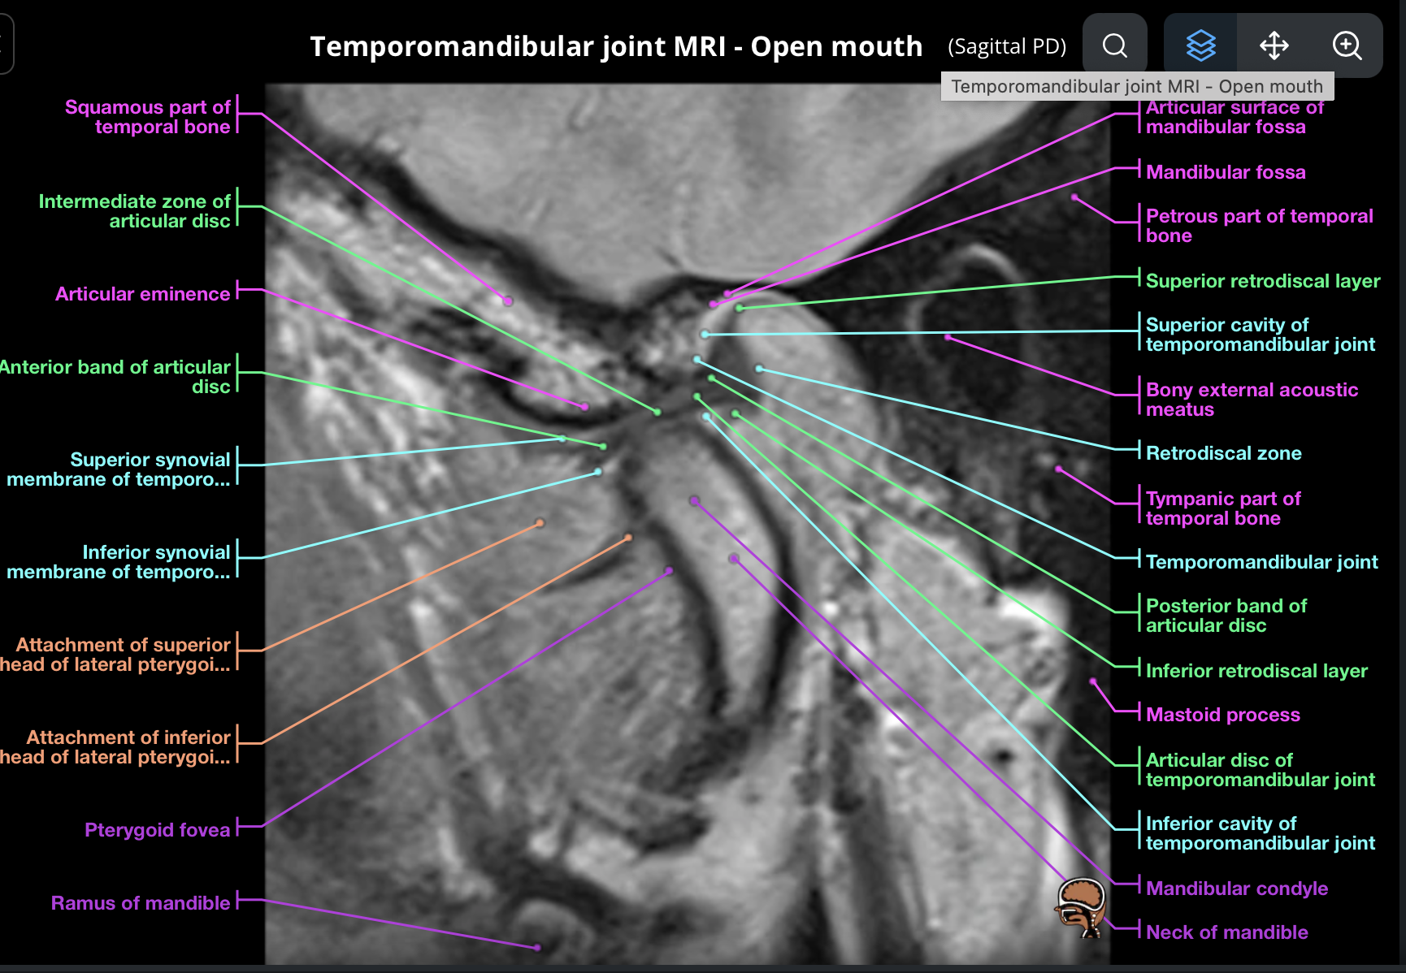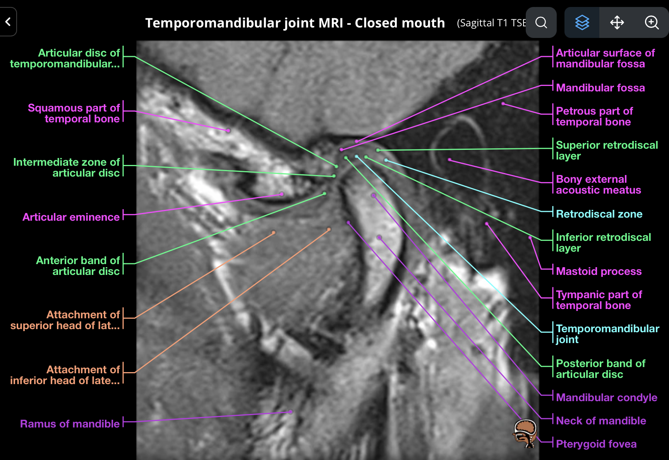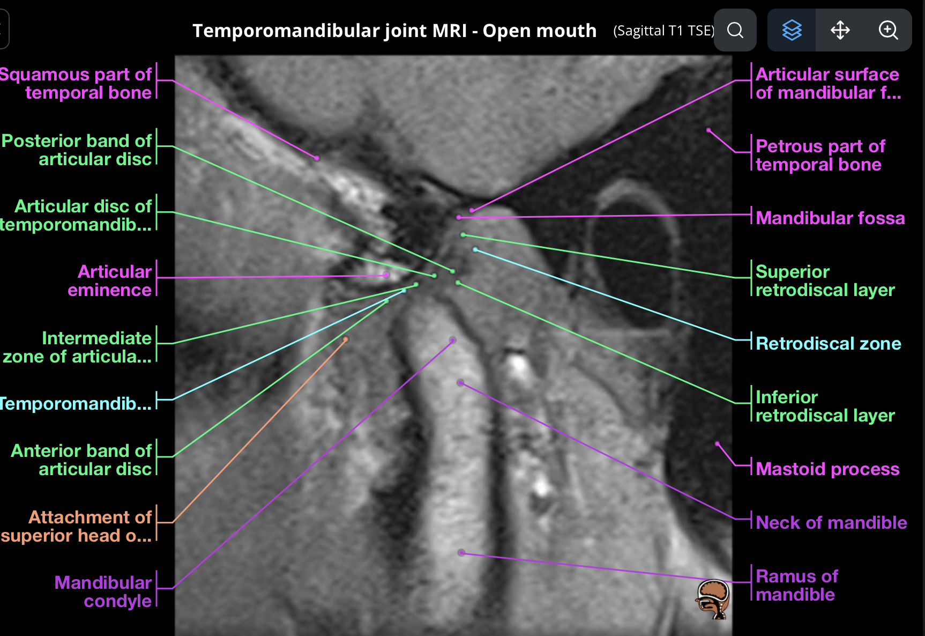

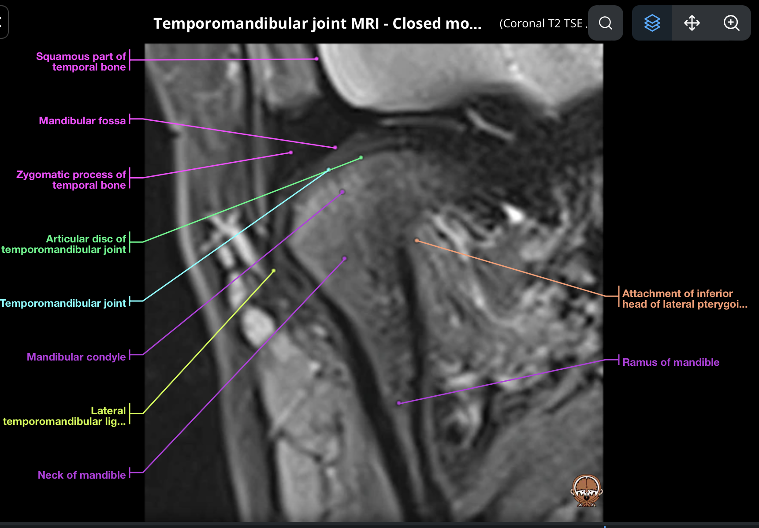

Important boundaries of TMJ:

*Superior:* Articular surface of temporal bone

*Superior anterior*: articular eminence

*Superior posterior* : EAC

*Inferior* : Mandibular condyle

In the joint cavity :

1. **Meniscus** – divided the joint cavity into superior and inferior recesses.
   1. Meniscus has three parts:
      1. Most important; posterior thickened part- this is held in place by bilaminar zone which attached it to the posterior temporal bone. The mandibular condyle rests on it in closed mouth. The mandibular condyle can be anywhere between 10-2 O’ clock position in relation to
      2. Intermediate thin part that articulates with condyle during open mouth
      3. Anterior disc.

**Example of normal anatomy** :

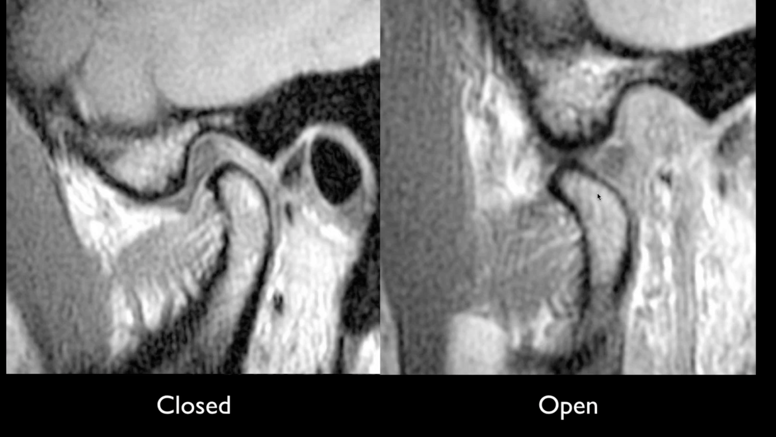

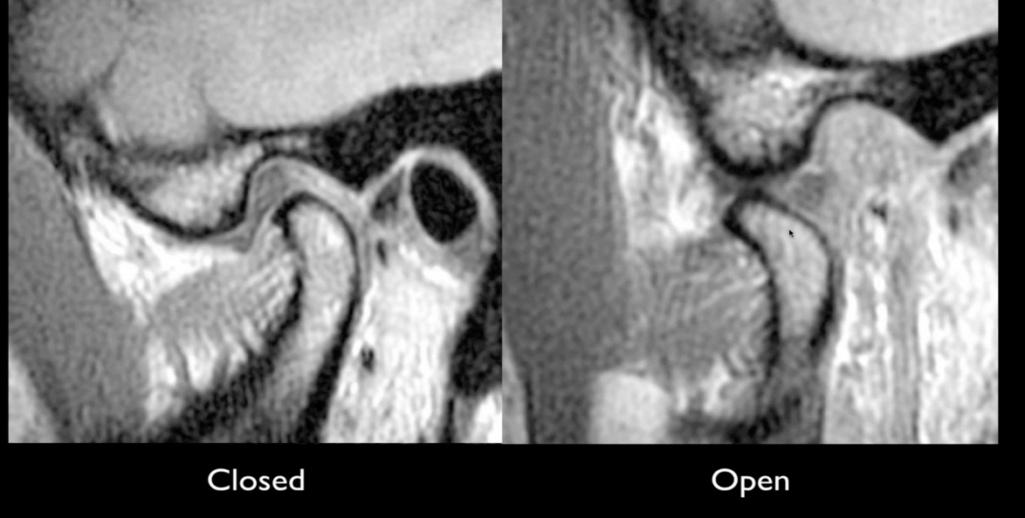

Intermediate thin zone for open mouth articulation



Bilaminar zone

Posterior thick meniscus disc

Anterior meniscus

***See below annotated images.***

**Report template and report checklist:**

Comment following in relation to disc:

1. Disc displaced:
   1. Anteriorly- most common
   2. Posterior displacement – very rare
   3. Lateral and medial displacement- very rare
2. Morphology of disc if it’s abnormal;
   1. Crumpled
   2. Rounded
   3. Flat
   4. Perforated
3. Movement of disc in relation to condyle in opening of the mouth:
   1. Reduction/ recapture present
   2. No recapture
   3. Stuck disc
4. Osteoarthritis
   1. Flattening of the condyle.
   2. Osteophytes
   3. Erosion
   4. Sclerosis
5. Indirect signs:
   1. Joint effusion
   2. Increased thickened of LPM attachment.
   3. Rupture of retro discal layers
6. Comment on arcuate eminence.

**Cases**

**1:**

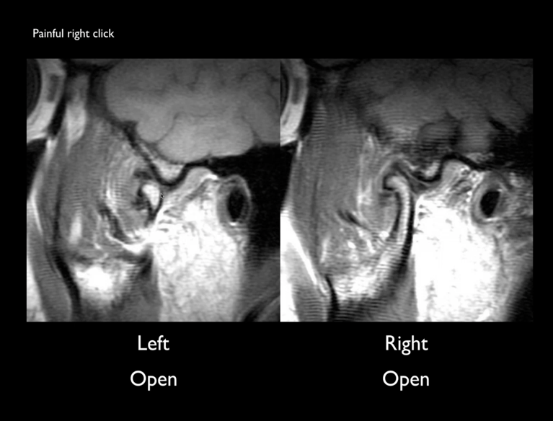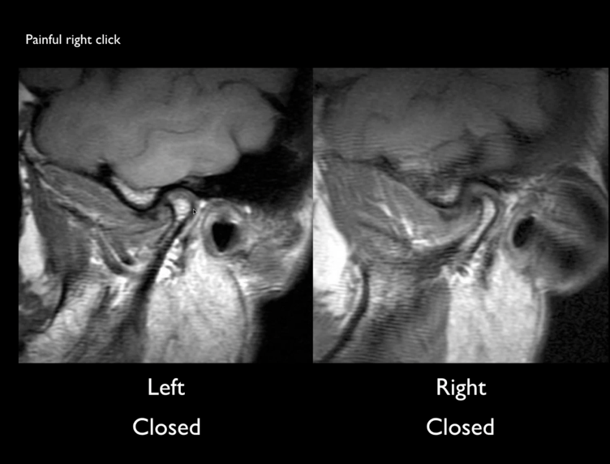Example of anteriorly displaced meniscus :

Findings :

Both right and left : anteriorly displaced disc :

In the left side- anteriorly displaced disc, which captures on opening the mouth.

But on right side- anteriorly displaced disc but no capture during open mouth- this patient has painful click on the left side.

Examples disc abnormal morphology;

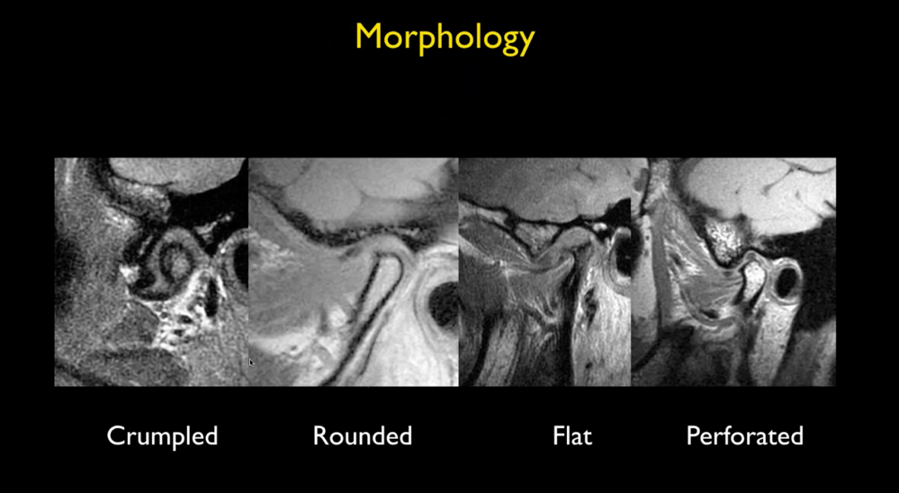

**Example of borderline disc displacement:**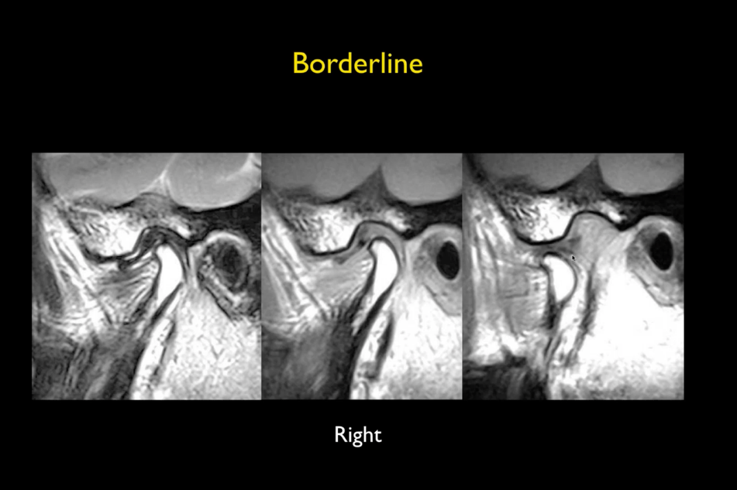

Findings :

Patient with left symptoms. TMJ of asymptomatic side.

The disc is borderline anteriorly located in closed mouth. No other abnormality.

Small amount of fluid in T2WI closed mouth (first image). Mild increase in signal of disc inT1WI- this is within normal range.

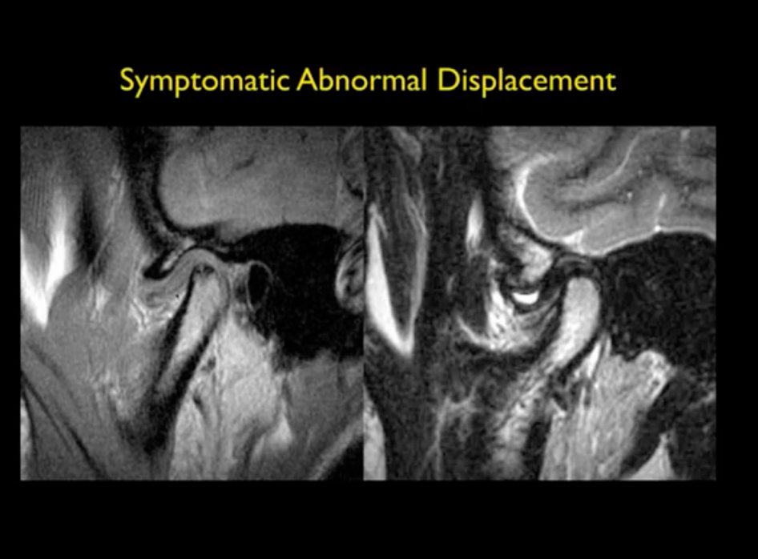

**Case 3:**

Findings :

Erosive changes of the mandibular condyle.

Morphology of the disc is crumpled.

Some fluid in superior recess- mora then normal’

Anteriorly displaced disc clearly seen.

**Case 4:**

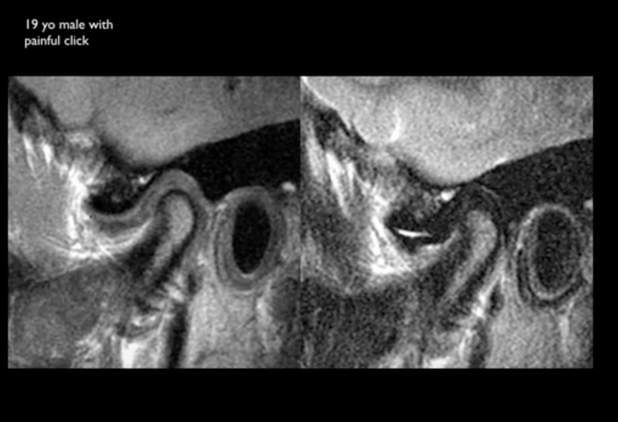

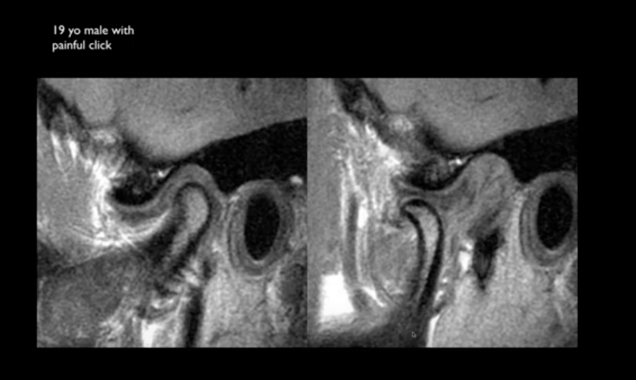

Findings :

Anteriorly displaced disc

Joint effusion

Flat morphology

Recapture present in open mouth

Tear of the retro discal structure.

Click due to recapture.

Case 5 :

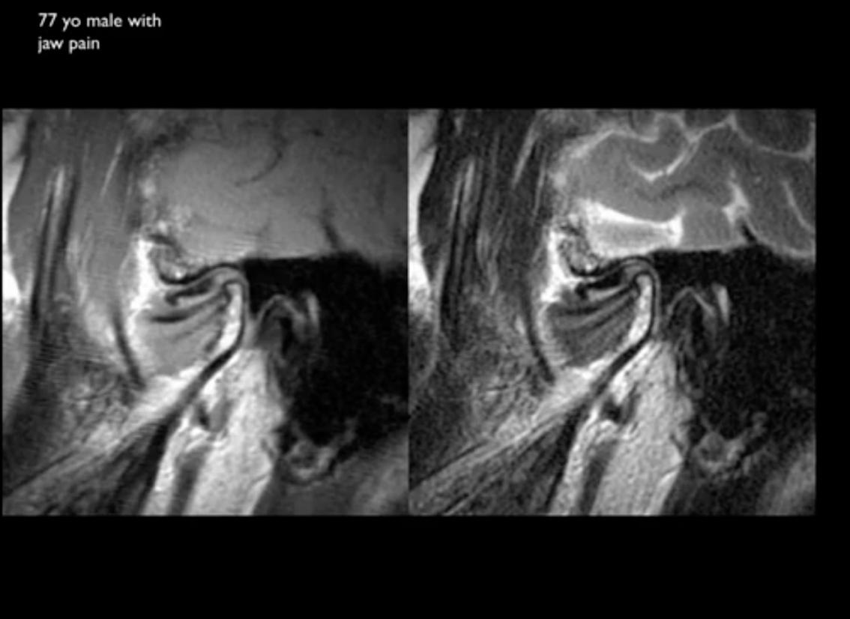

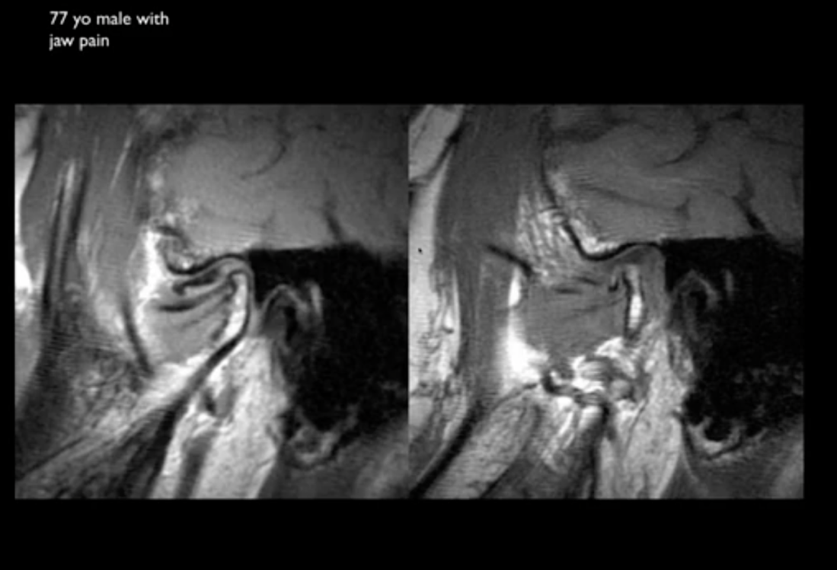

**Findings:**

Hypoplastic condyle

The disc is anteriorly displaced.

Torn retro discal structure.

Normal signal of the disc

Rounded to crumpled morphology.

Open mouth: recapture is present but reduced anterior translation (inadequate anterior translation). The reason why there is inadequate condylar movement is not due to restriction cause by the disc, but instead due to either poor effort due to pain (then both sided will poorly translate – even the contralateral asymptomatic side) OR due to adhesions (the asymptomatic side will have normal translation).

Small condyle – may point to rheumatoid arthritis.

Case 6:

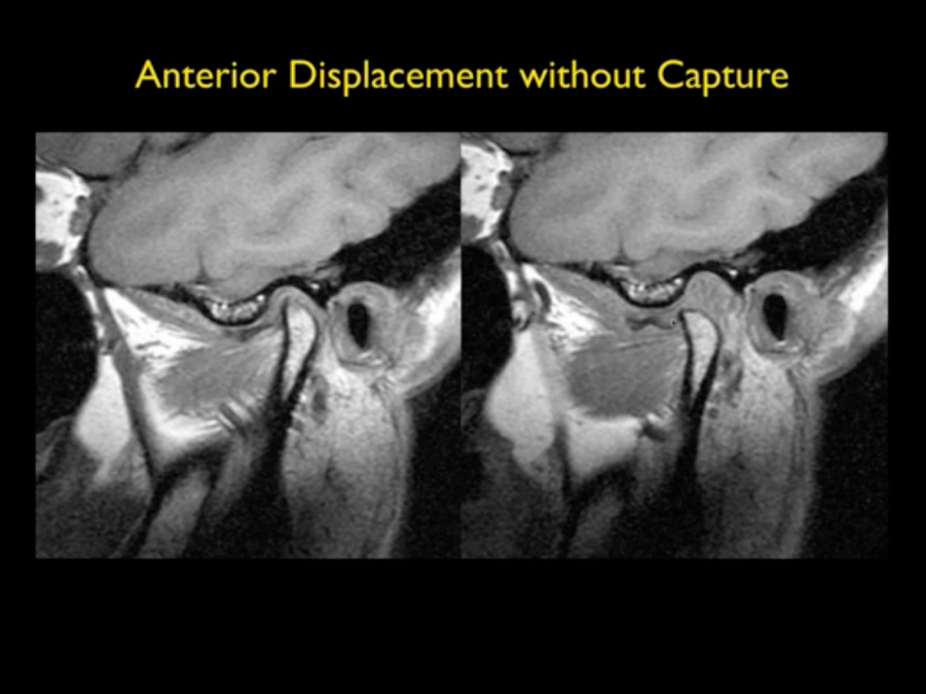

Case 7:

See following images and then describe the findings :

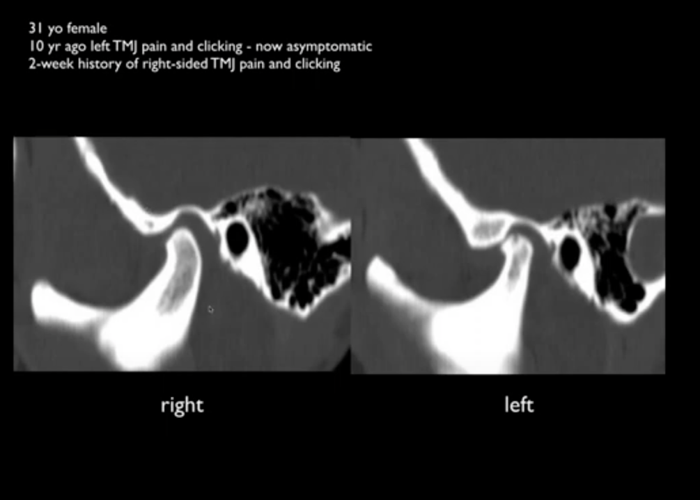

Findings :

Reduced joint space on left side.

Condylar osteophytes and loss of normal condylar shape on left side. A condylar erosions.

I note that his is currently asymptomatic site- but there are advanced osteoarthritic changes on this side with reduced joint space suggesting a displaced disc. I will do MRI next.

On right side There doesn’t seams to be much abnormality in CT. I will do MRI to assess for cause of right sided pain.

….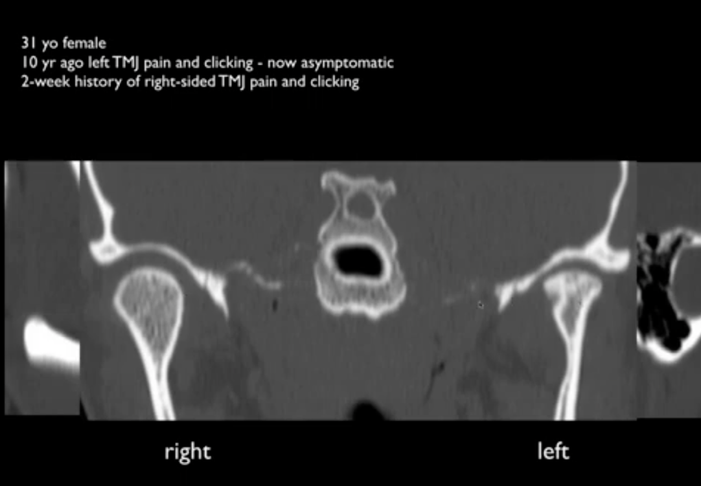

SO hear comes the MRI:

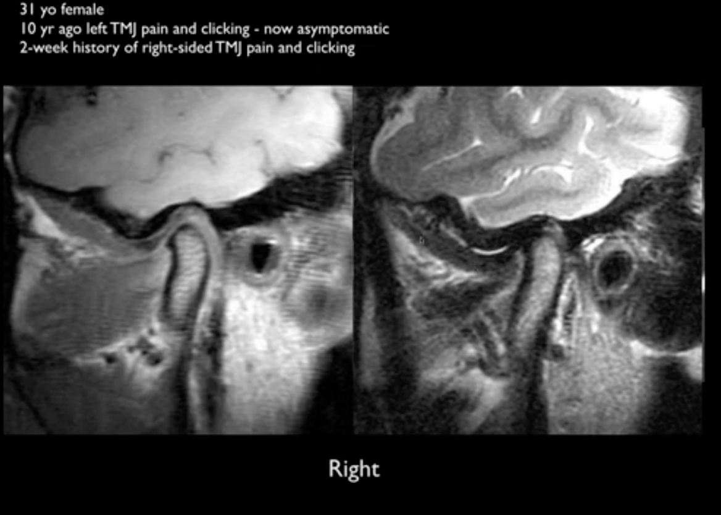

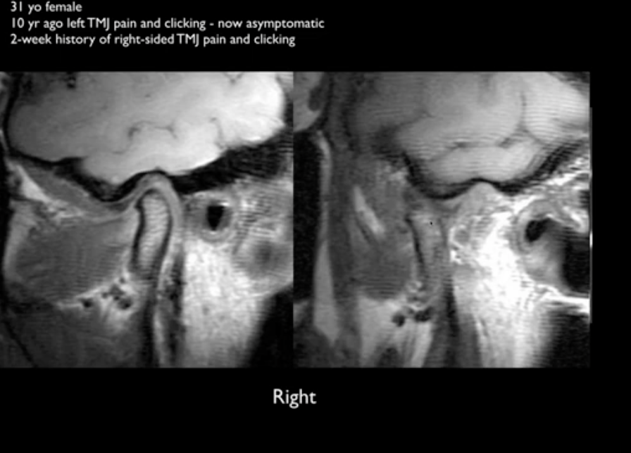

Findings :

Closed moth T1 and T2WI

Followed by open mouth view:

Findings are :

May be borderline anterior displacement of the condyle. But no other abnormality.

Joint effusion within normal limit.

Normal anterior translation- may be a wee bit hyper anterior translation,

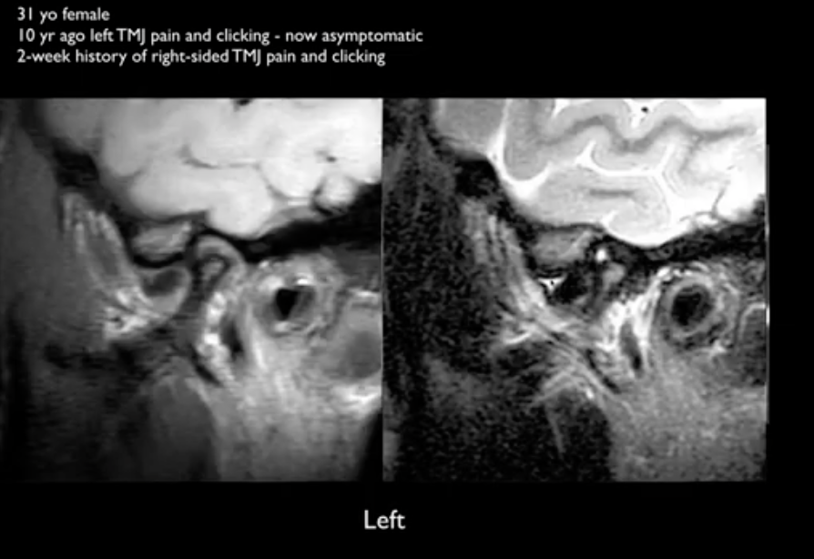

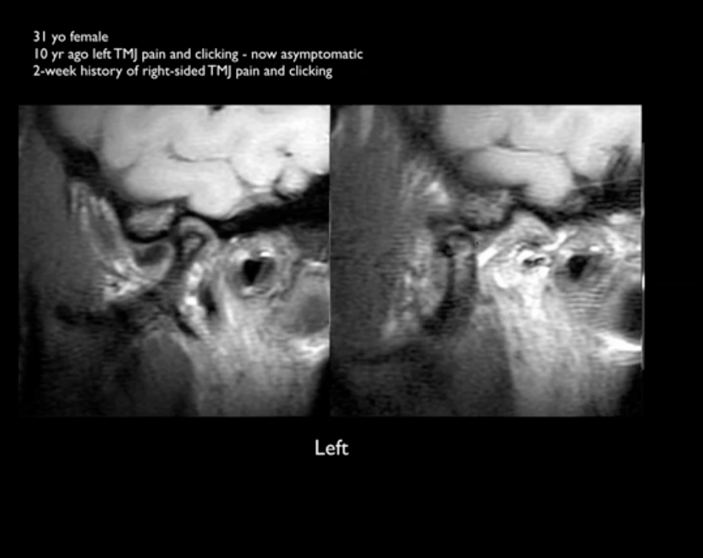

Left T1 and T2WI closed mouth followed by

Left closed and open mouth:

Deformed condyle

An anteriorly displaced disc- showed rounded appearances.

A perforation in disc present

Disruption of retro discal mechanism

Joint effusions present both in superior and inferior recess.

No recapture.

So what happens here is that, the asymptomatic side is asymptomatic because the nerves eventually destroyed and the abnormal joint become asymptomatic.

**Case 8:**

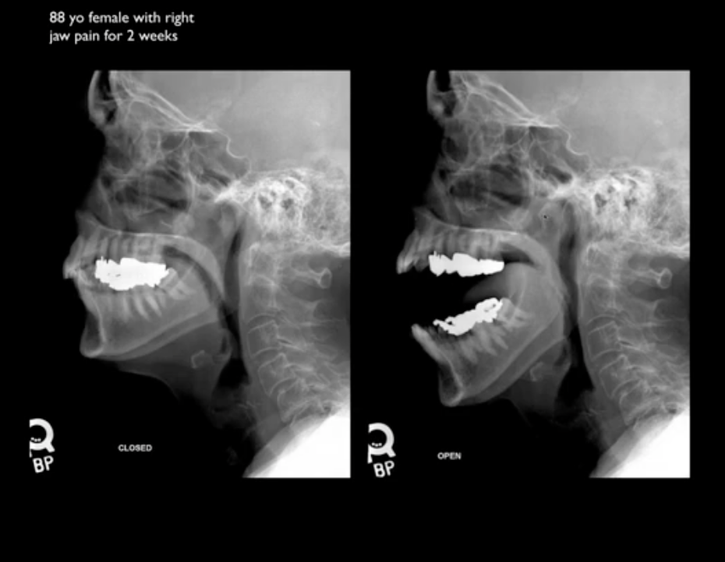

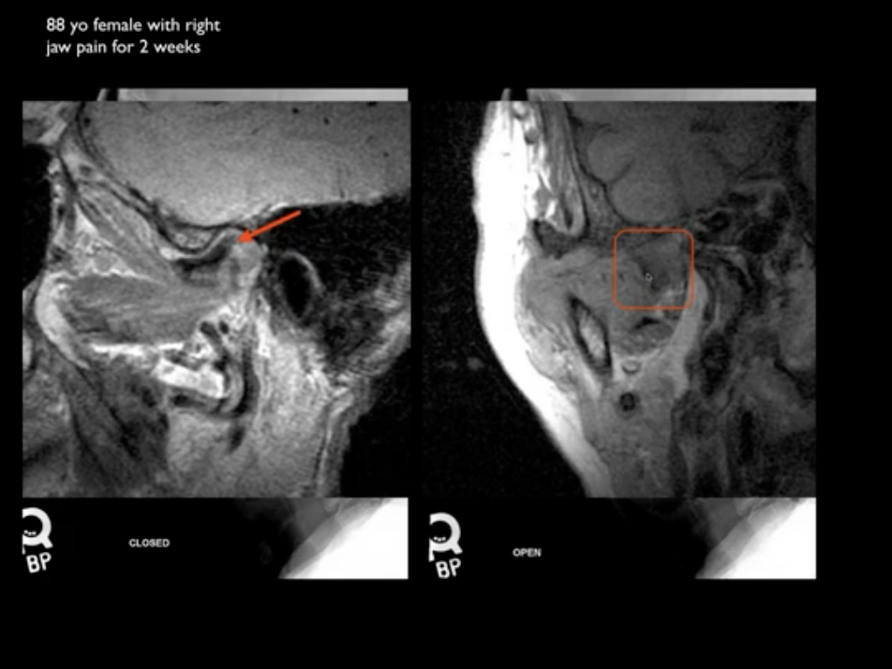

Findigns :

Radiogrpah shows reduced joint space but normal anterior translation of condyle.

In MRI- open and closed mouth views we see displaced disc but we don’t see condyle. So it means the condyle is not in same plane as the condyle. So look at coronal images- which will confirmed medially or laterally displaced disc rather then usual anterior displacement.

Case 9:

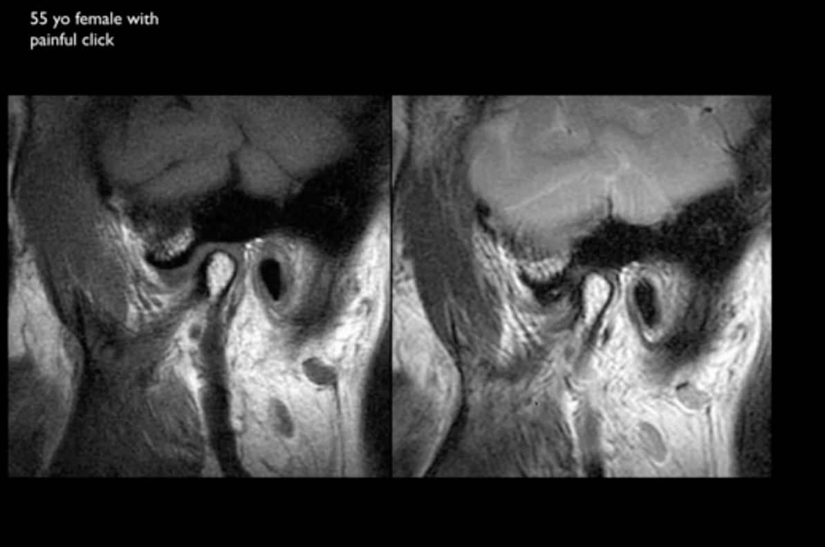

Closed T1 and T2WI

Anteriorly displaced disc with degenerative changes in disc and condyle.

Now open mouth view :

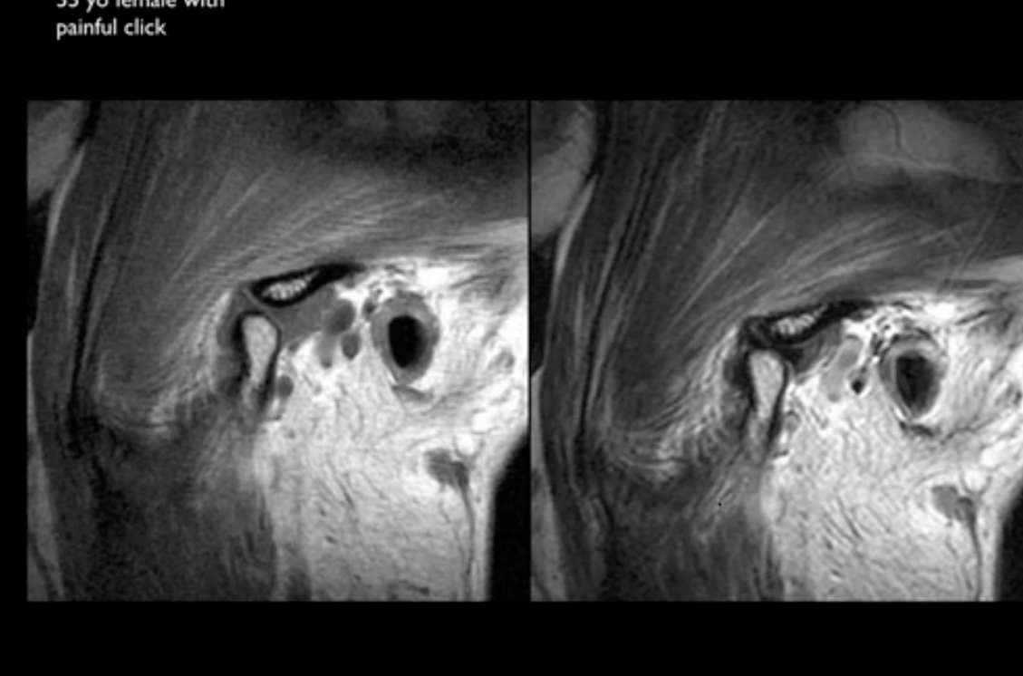

We see no recapture in this view .

Now see coronal images :

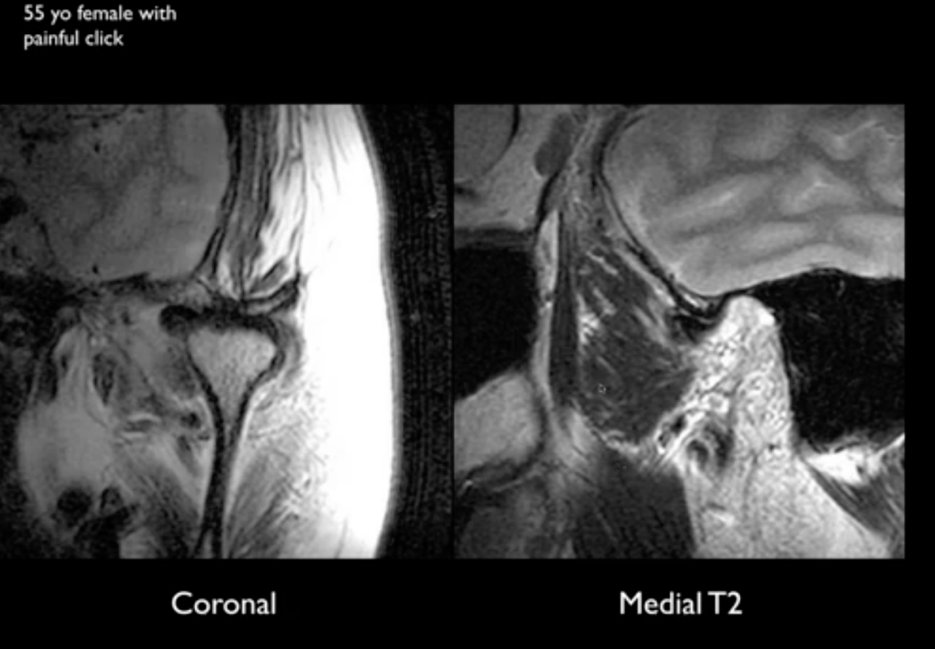

Medially displaced disc !!!

So diagnosis is anteriorly and medially displaced disc with capture.

**Case 10:**

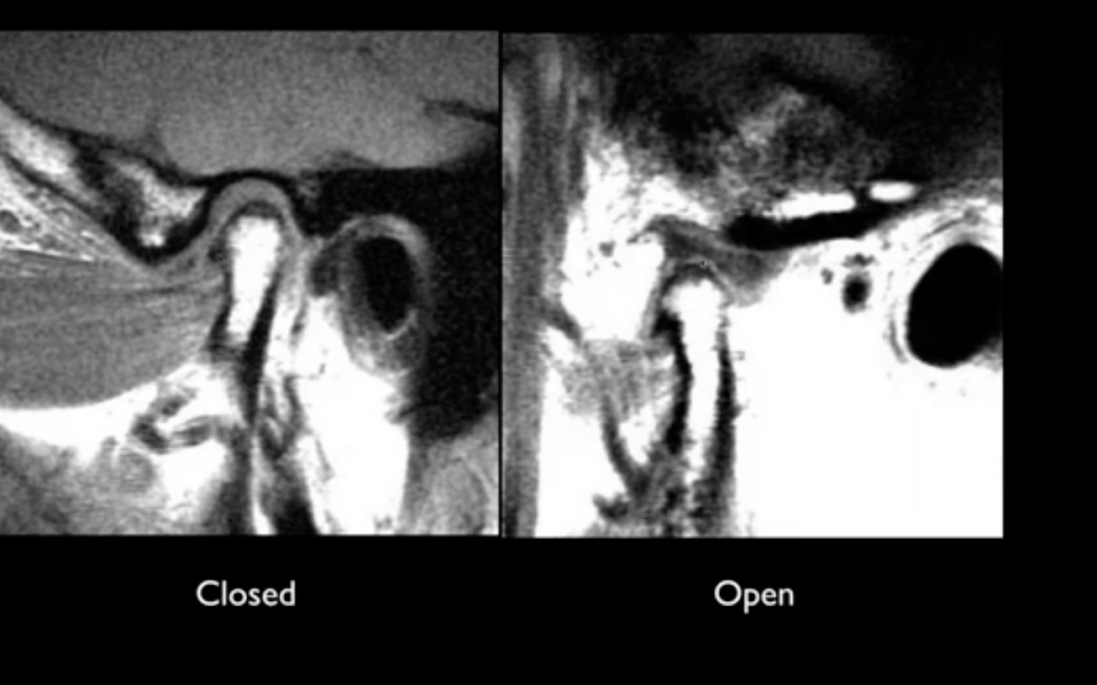

IN open mouth we clearly see disc in good place. But NO disc is seen in closed view !!

Why ??

Look for disc in more medial or lateral slices then : there could be medial displacement !

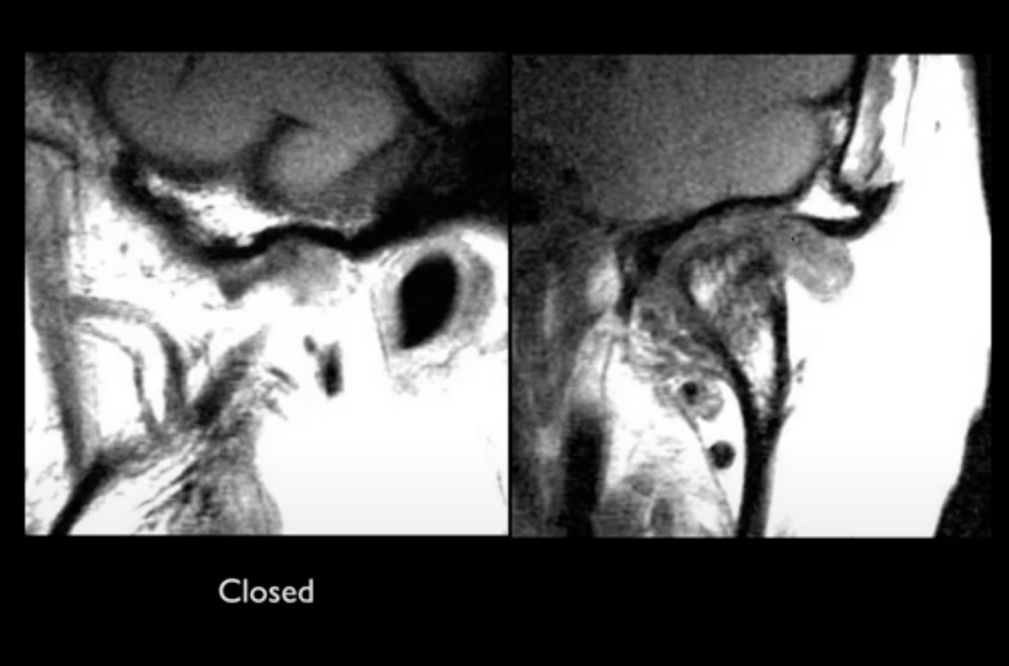

There you go !! Lateral displacement.

**Case 11:**

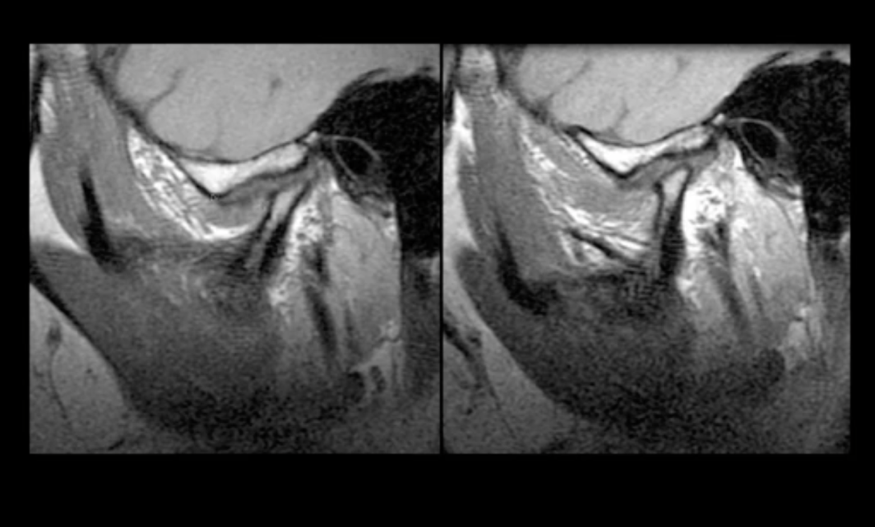

Findings :

Closed and open mouth T1

A very abnormal condyle

Flat disc which is anteriorly displaced.

No translation in the open mouth and no recapture

There is abnormal appearance of arcuate eminence

Diagnosis : Condylar flattening – post traumatic

Below post traumatic cystic changes :

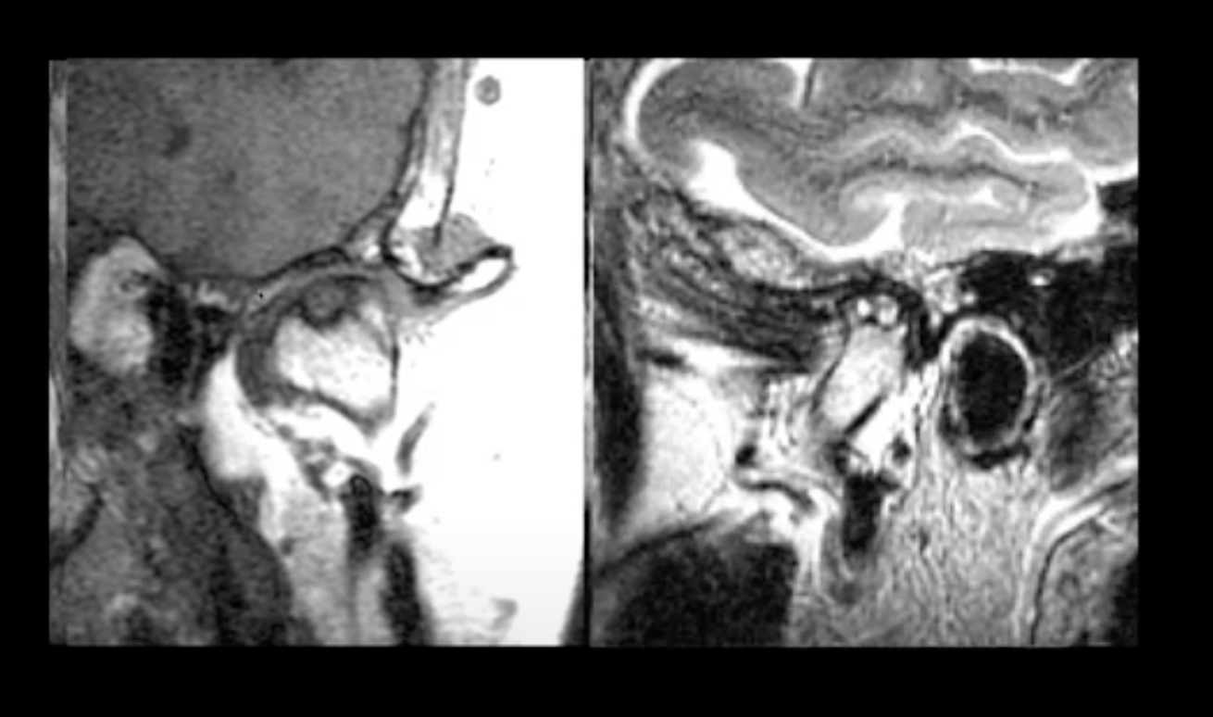

**Case 12 :**

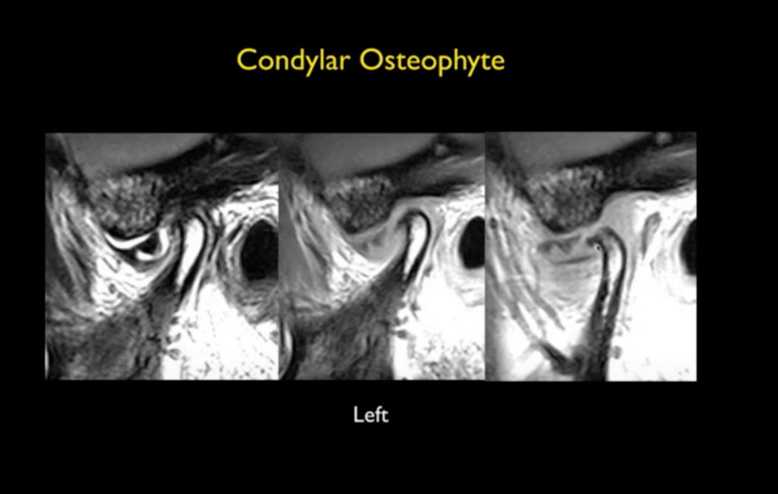

Findings :

Anteriorly displaced disc

Rounded morphology

Large joint effusion

Flattened condyle with anterior osteophyte.

No recapture in open mouth.

Another example of severe DJD

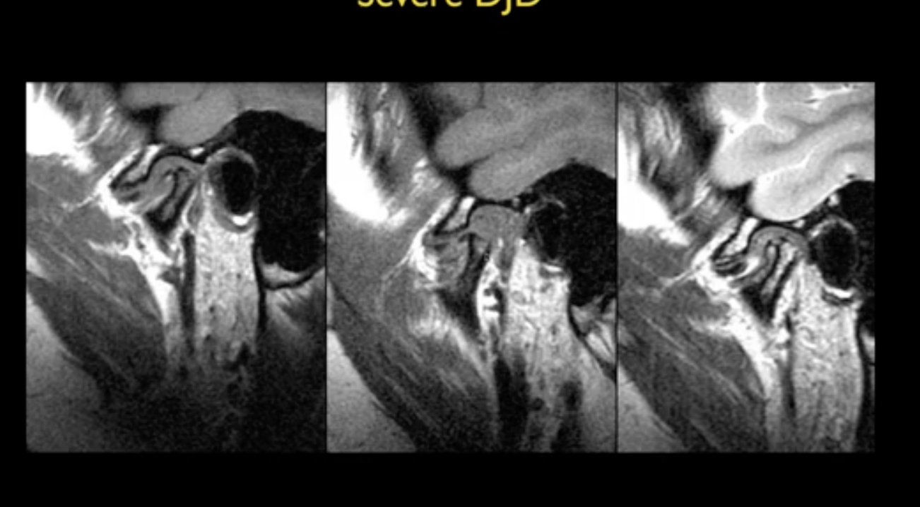

Notice osteophytes and lack of recapture

Another example below; notice arcuate eminence osteophyte:

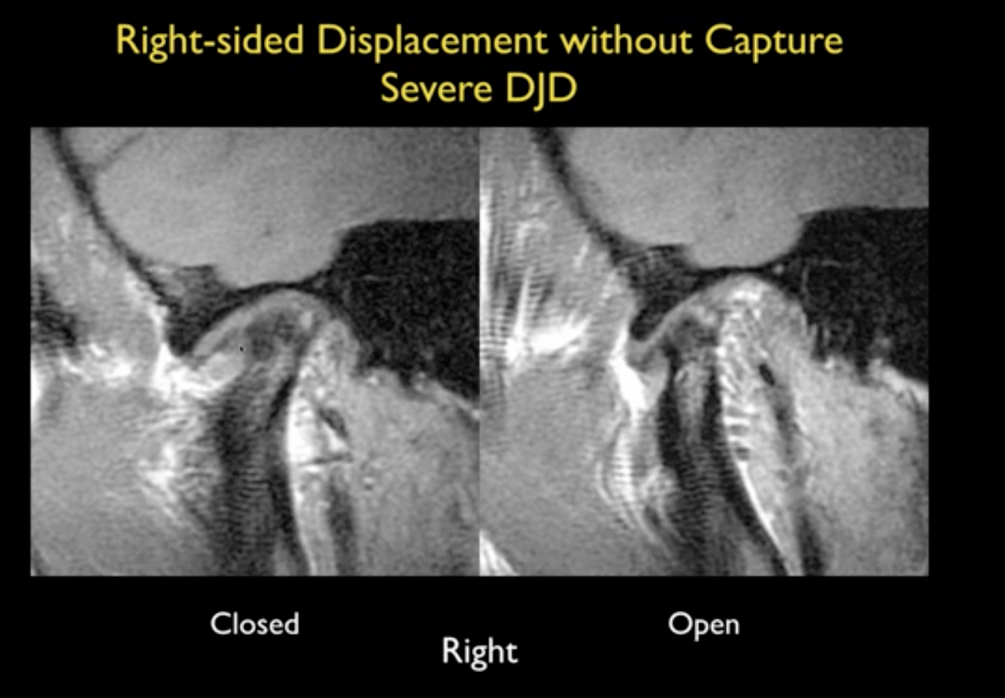

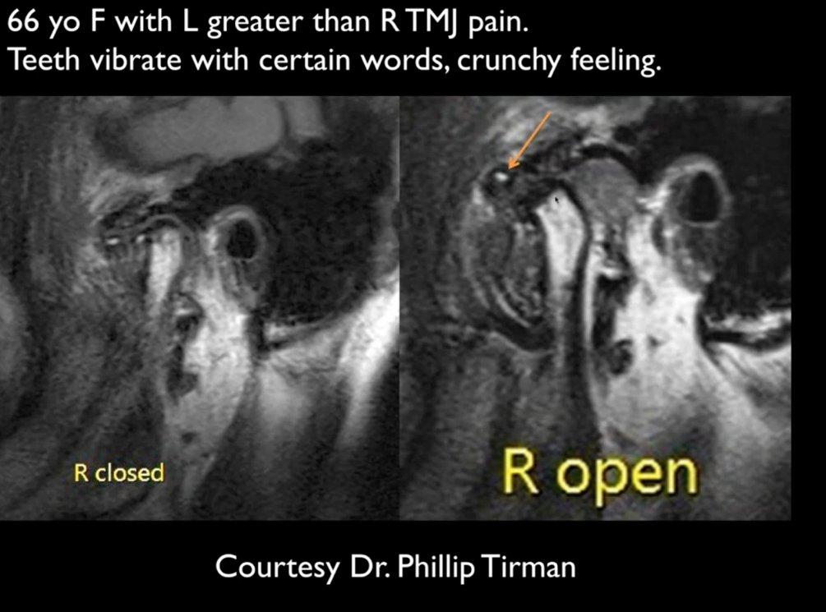

4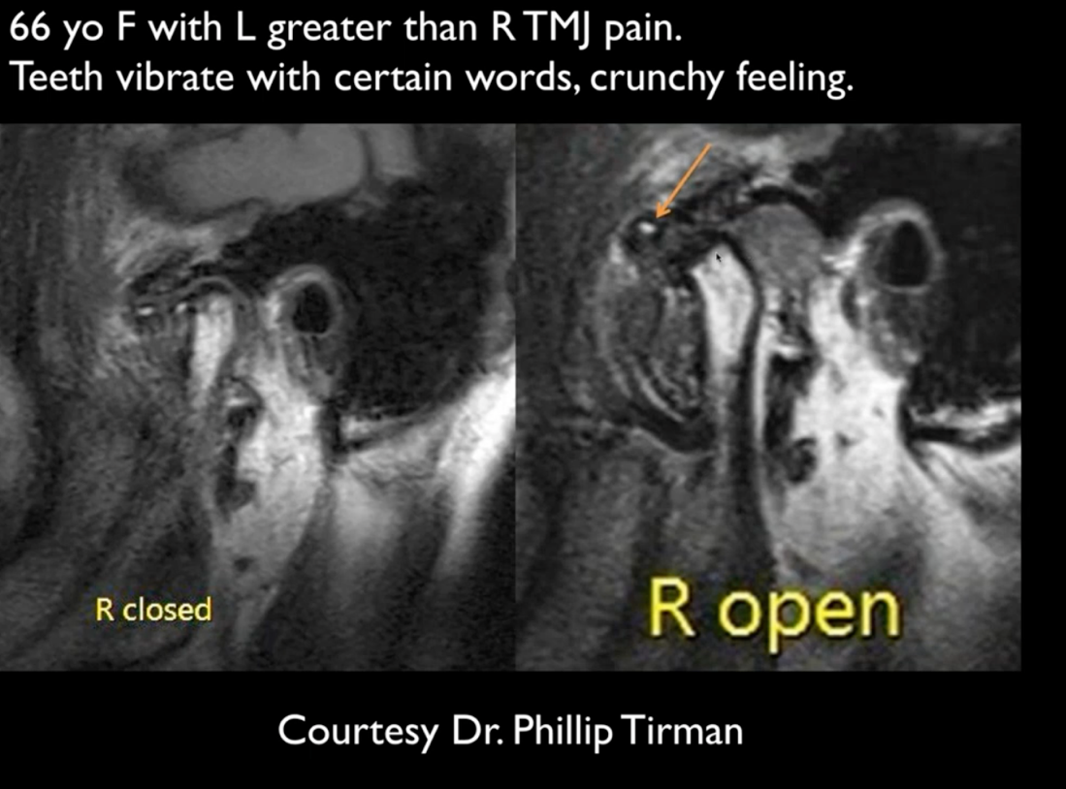

3

1

2

4



#1 : Condylar sclerosis

#2 Bone to bone contact- disc largely resorbed

#3 : osteophyte

#4 : loose body.

Trauma in boxer: impacted fracture of right EAC !

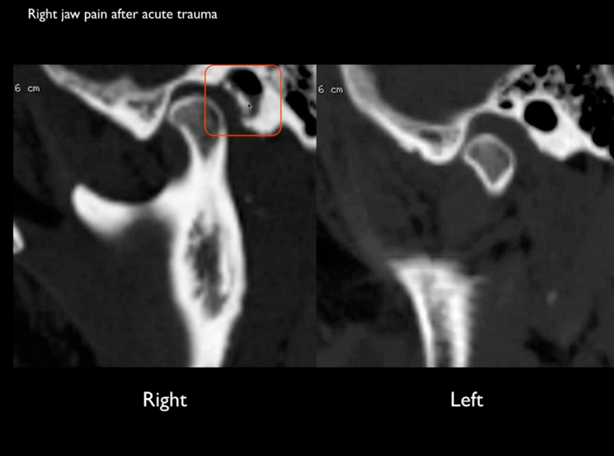

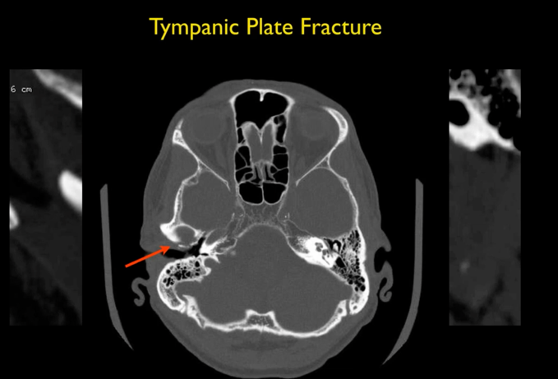

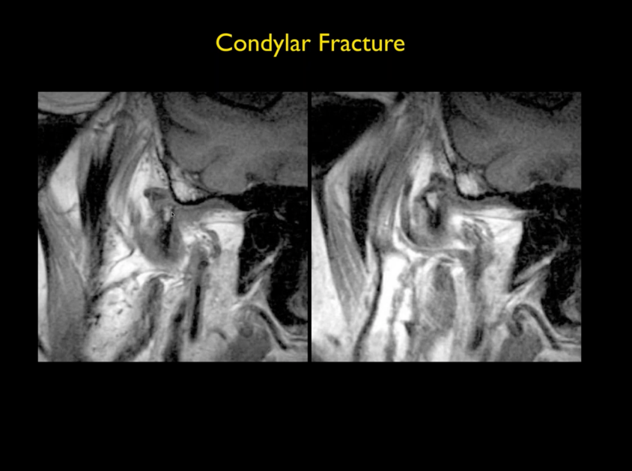

CONDYLAR FRACTURE !!!!

**CASE 13:**

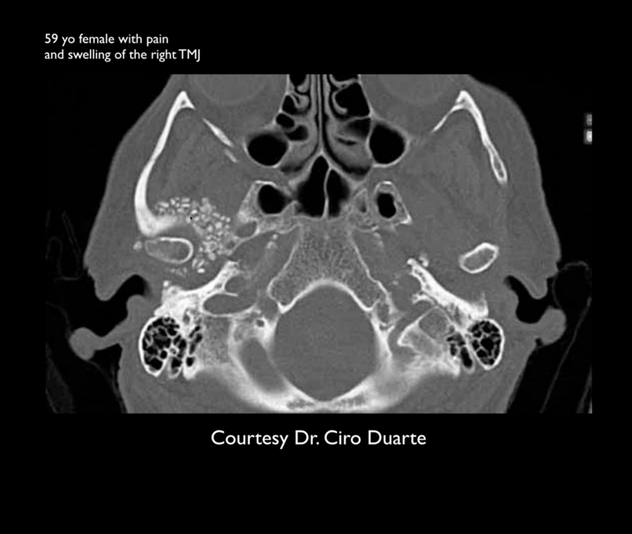

SYNOVIAL CHONFROMATOSIS

CASE14

Mitek suture :

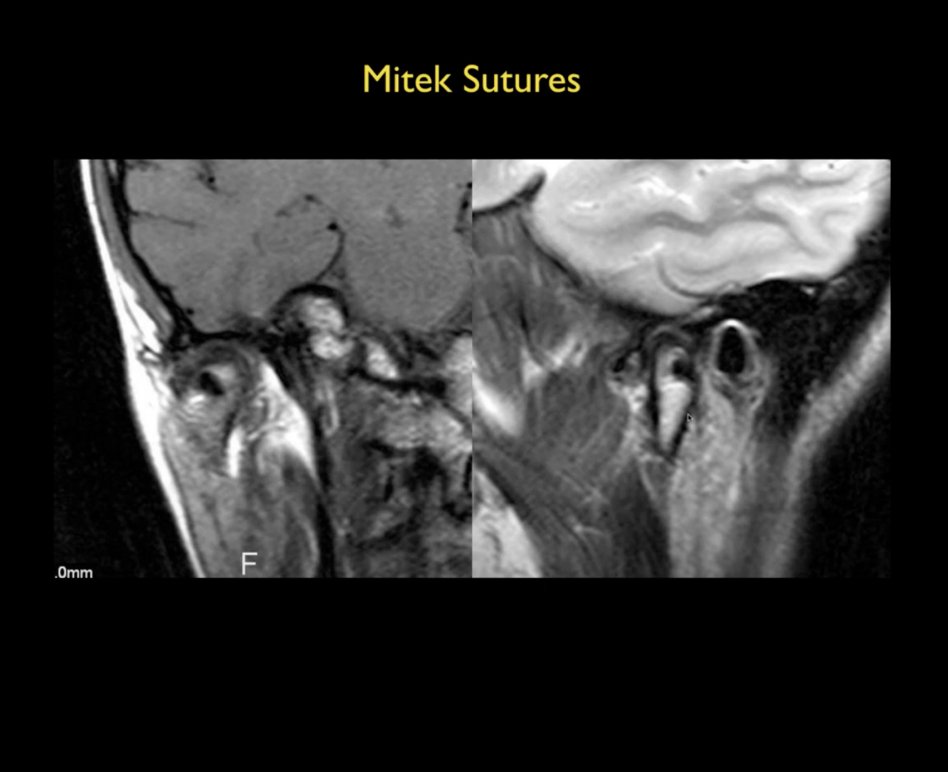

**Case 15:**

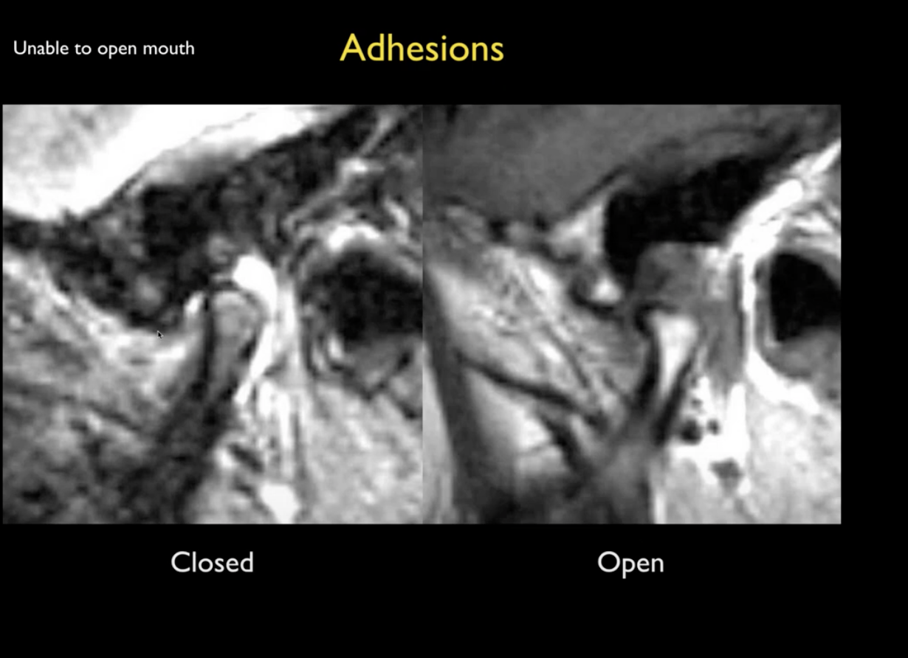

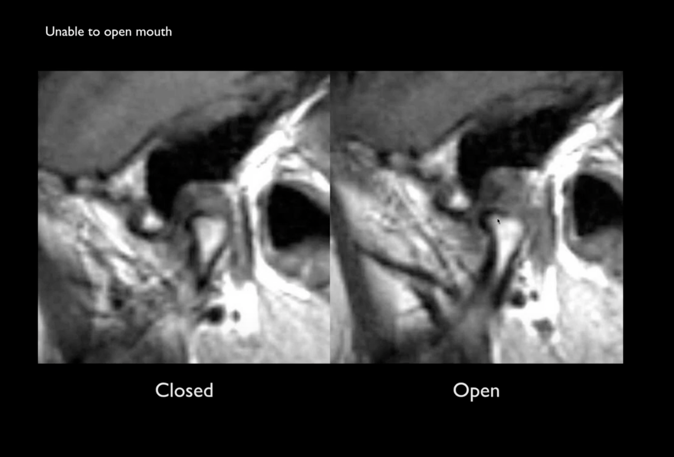

Findings :

Irregular condyle

The disc is located at normal position.

But there is a lot of fluid in joint

And also in open mouth there is hardly any anterior movemyn of the condyle.

Bottom line: TMJ disease is common. 11 % world population is symptomatic.

But MR findings do not directly correlate with the degree of symptoms.

There is not much we can do about MRI FINDINGS.

**Night splints is most popular way of treating the TMJ disease- recommended for pretty much every one !!!**